Visit Report: Kamalnagar Upazila Health Complex, Lakshmipur
Date of Visit: 13/09/22; Time: 9:00 AM.
Visitor: Dr. Md. Emdadul Haque, National Consultant (SSK) &
Dr. Nazmur Rahman Sajib. Junior National Consultant (SSK)

Objectives of the visit:
1. To assess the progressive development of the quality of health care
2. Discussion about the importance of quality of health care.
3. Formation of quality improvement committee (QIC)
4. Improvement of the quality by implementing the building blocks of C-J Model.

Activities at UHC:
1. We arrived at Kamalnagar UHC at 9:00AM, and participate in a discussion meeting regarding the importance of quality of health care with UH&FPO, RMO and other members of Quality Improvement Committee (QIC) in the conference room. Dr. Nazmur Rahman Sajib discussed about the importance of quality of health care by a power point presentation & Dr. Emdadul Haque discussed about the building blocks of C-J Model. We also discussed with them about SSK program and the overall situation of health complex.

2. We observed the development of UHC's healthcare services while performing a site inspection of the hospital. We have seen lot of improvements, such as those we had suggested on our earlier visit on 1st August 2022, including improvements to the cleanliness, beautification, and waste management systems.

Positive changes are shown below:
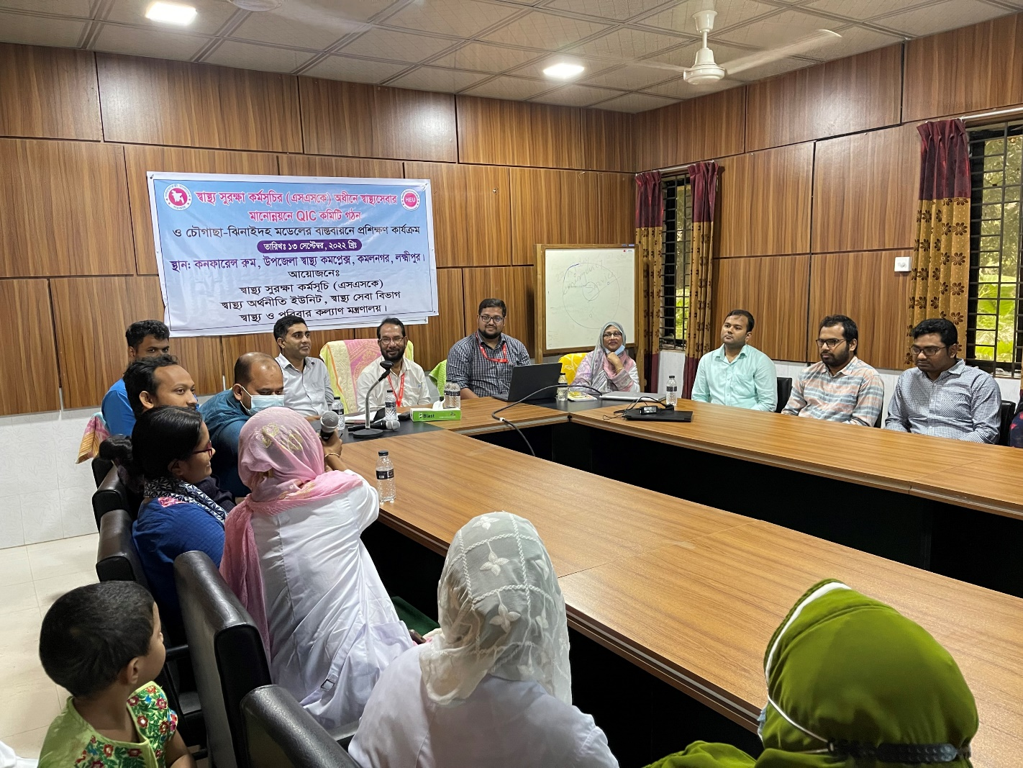

Fig-1: Training on Quality of Care and formation of QIC committee

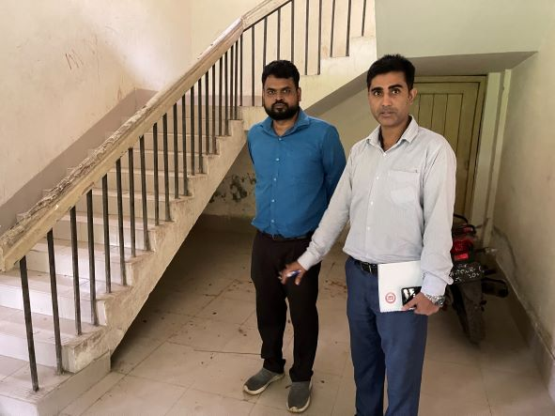
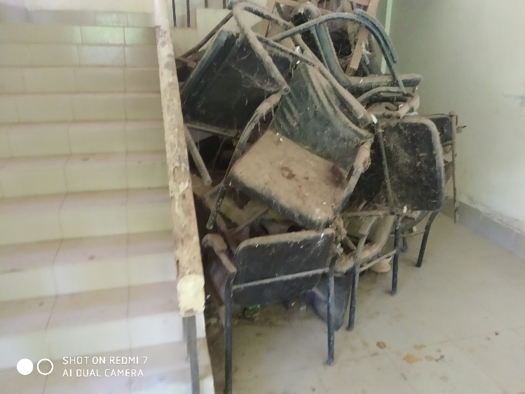
AFTER
BEFORE

Fig-2,3: Removal of unwanted items from hospital premises (Positive Changes)

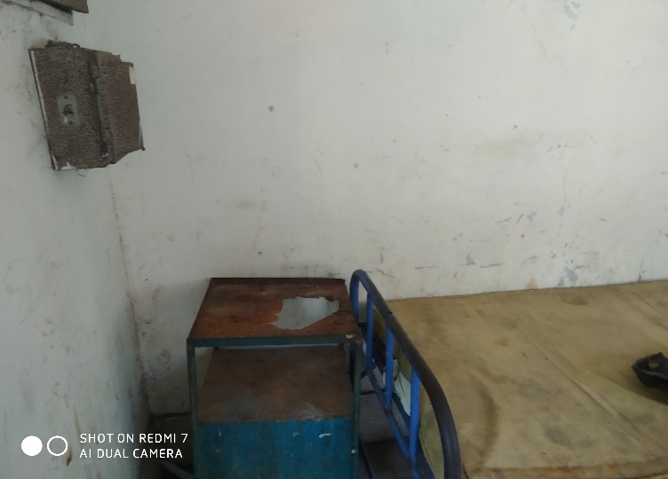
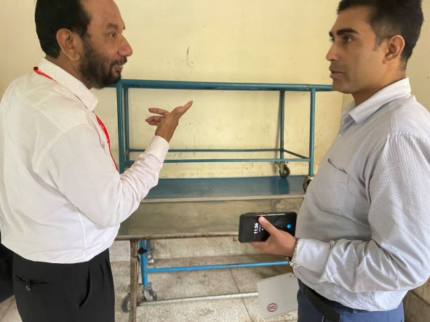
AFTER
BEFORE

Fig-4,5: Removal of unwanted items from hospital premises (Positive Changes)

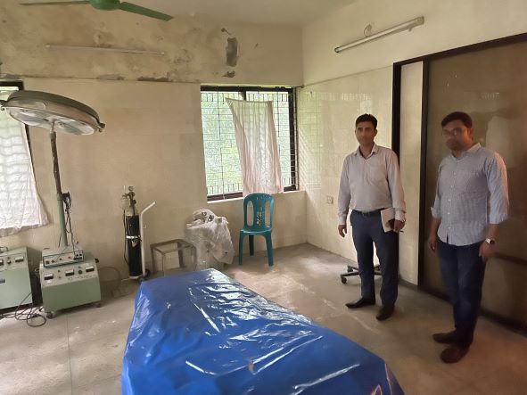
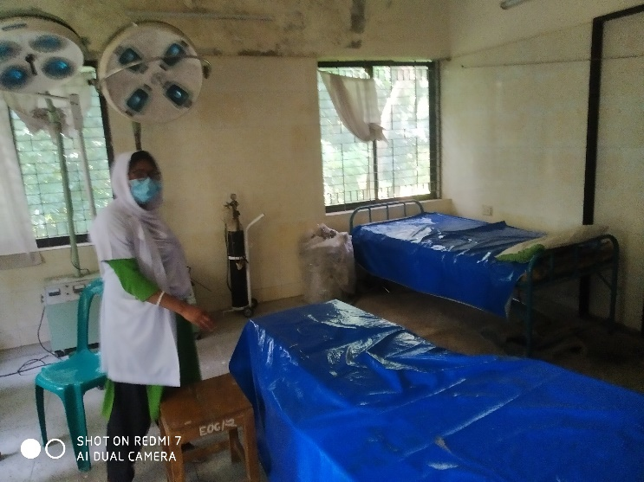
AFTER
BEFORE

Fig-6,7: Removal of unwanted items from OT (Positive Changes)

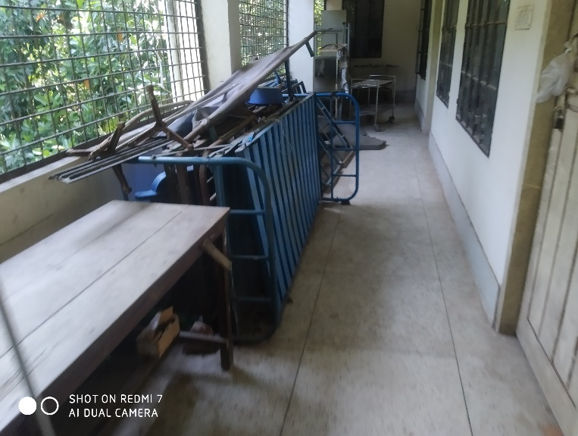
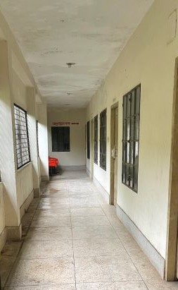
AFTER
BEFORE

Fig-8,9: Removal of unwanted items from the corridor (Positive Changes)

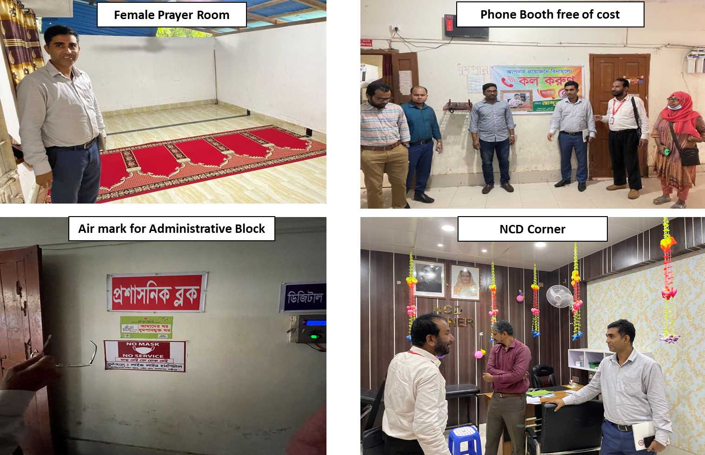

Fig-10-13: New Innovations by UHC

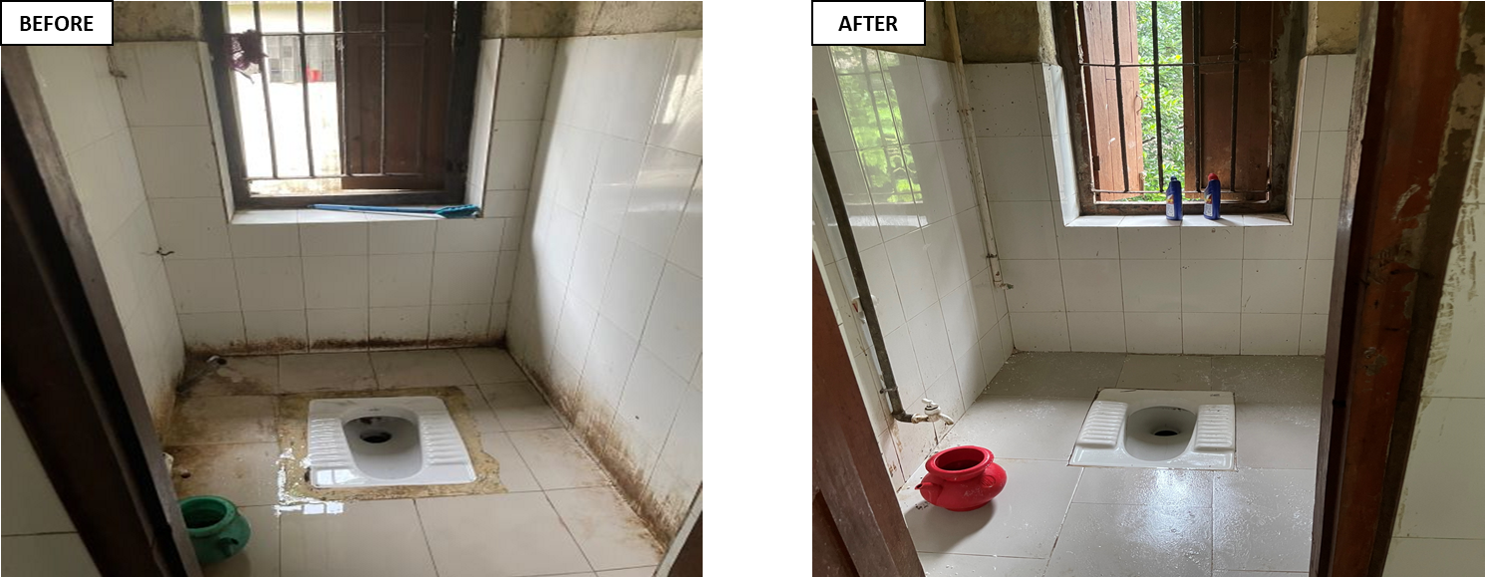

Fig-14,15: Improved sanitation system (Positive Changes)
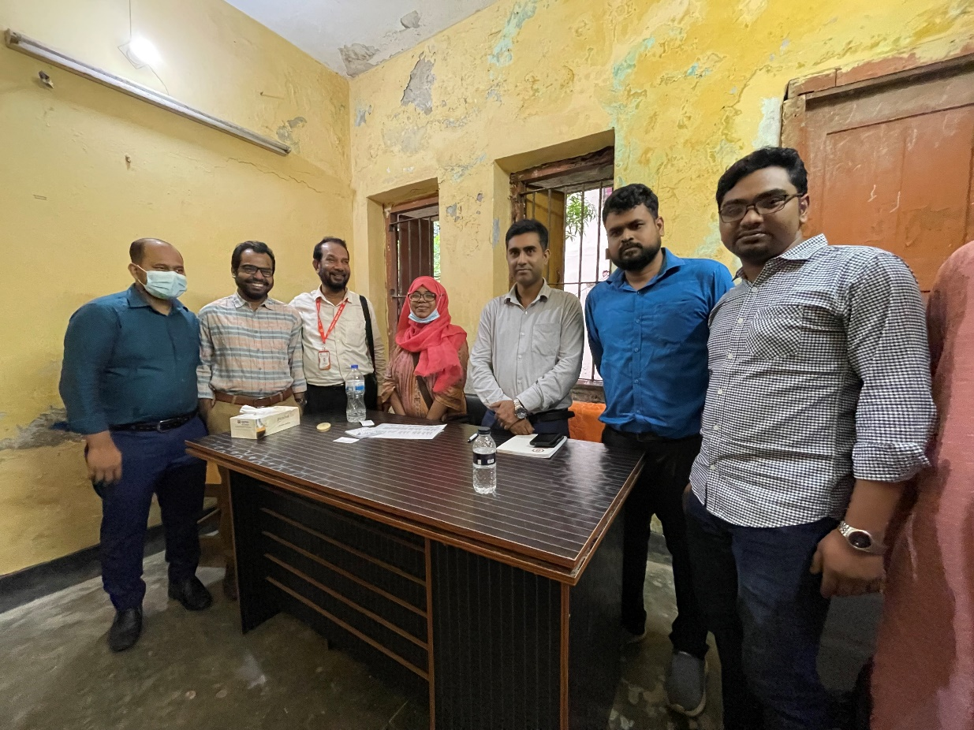

Fig-16: New desk funded by Medical Officer

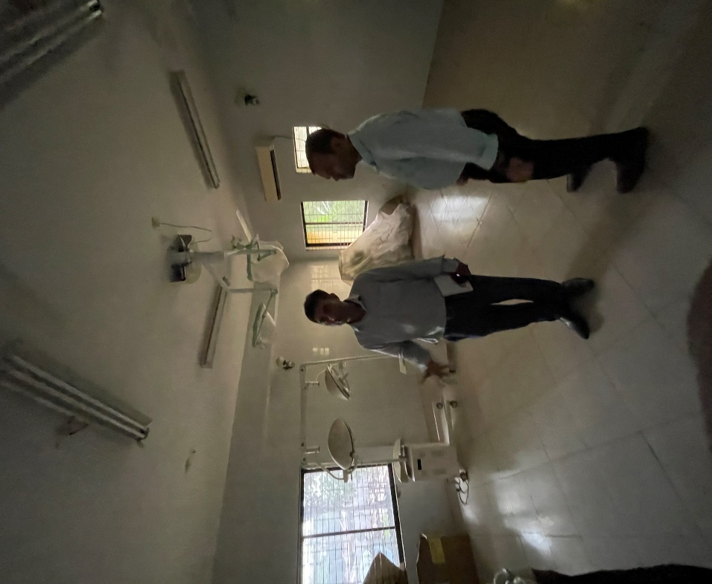

Fig-17: Preparation of OT room in new building

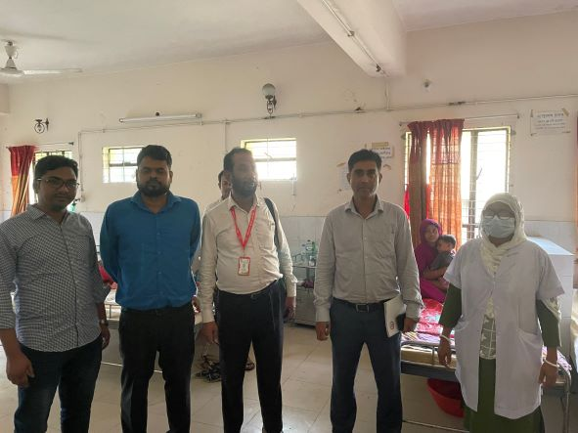
Fig-18: Opened a pediatric ward by local initiatives

Recommendation:
1. For functioning of the OT service, deputation of gynae consultant should be cancelled. An anaesthesia consultant already working there. But there is no anesthesia machine and OT table, which can be replaced from the other UHC where extra machine is available.
2. There are some proposed places near emergency dept. where SSK booth and Pharmacy can established.

